**Coding Assessment – Pyspark**

**Pyspark setup**

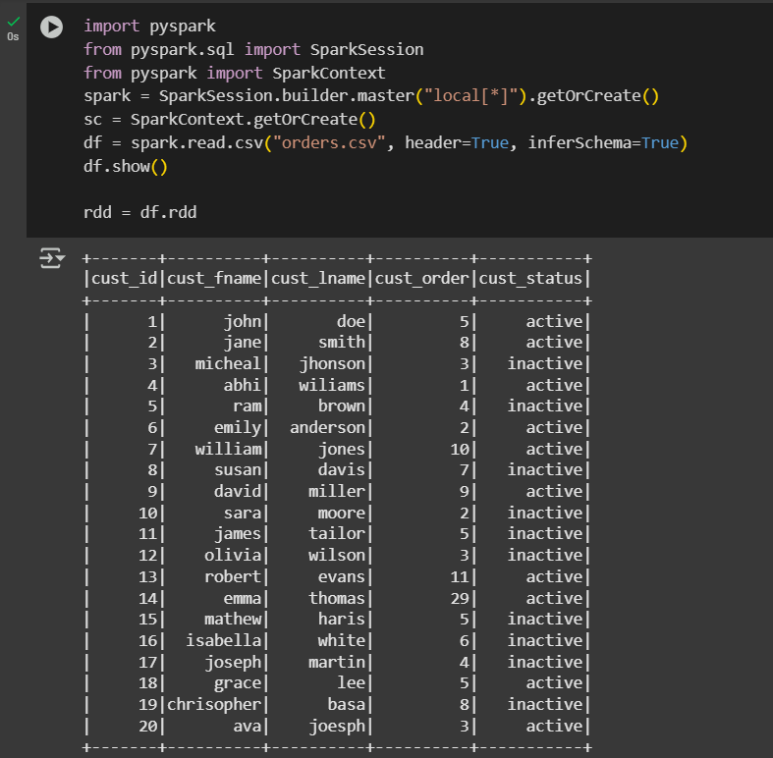

**Transformations in PySpark**

* map() Transformation
* filter() Transformation
* union() Transformation
* flatMap() Transformation

**# Transformations in PySpark**

# map() Transformation

map_rdd = rdd.map(lambda row: (row['cust_fname'], row['cust_order']))

map_rdd.collect()

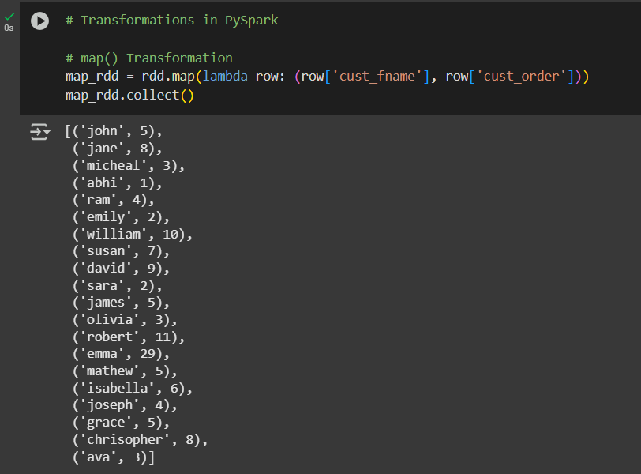

# filter() Transformation

filter_rdd = rdd.filter(lambda row: (row['cust_status'] == 'active'))

filter_rdd.collect()

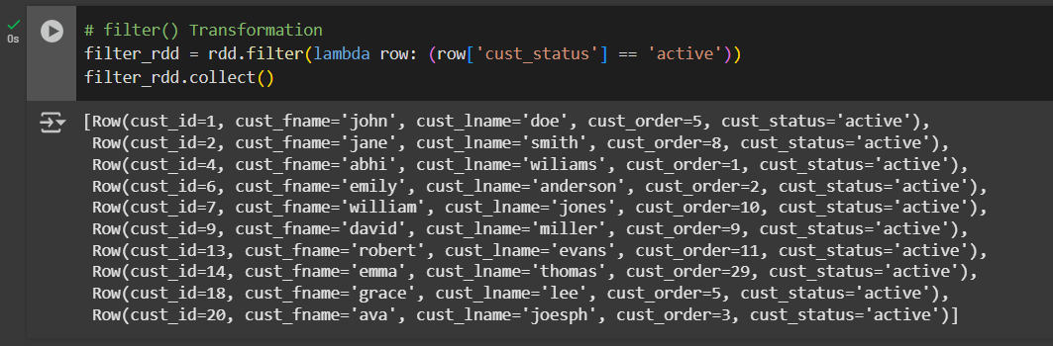

# union() Transformation

from pyspark.sql import Row

test_orders = spark.sparkContext.parallelize([

Row(cust_id=21, cust_fname='demo', cust_lname='user', cust_order=1, cust_status='active')])

union_rdd = rdd.union(test_orders)

union_rdd.collect()

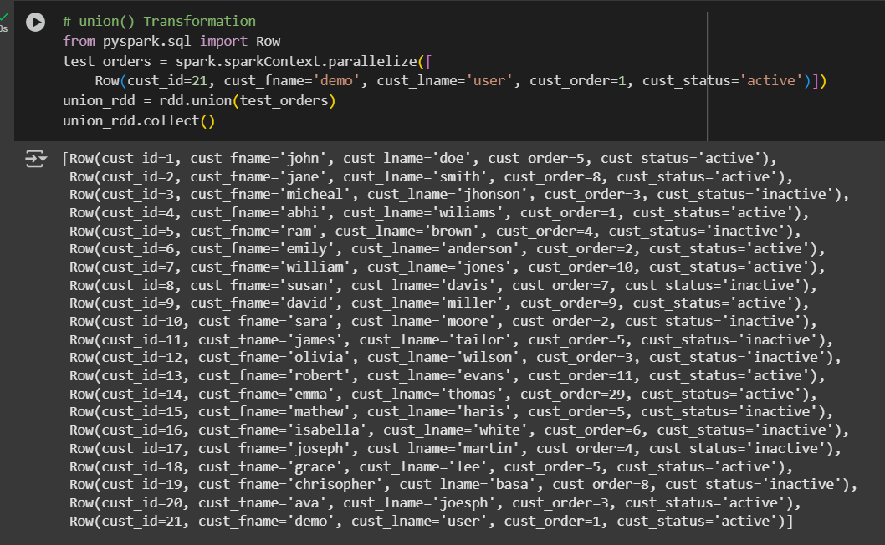

# flatMap() Transformation

flatmap_rdd = rdd.flatMap(lambda row: [row['cust_fname'], row['cust_lname']])

flatmap_rdd.collect()

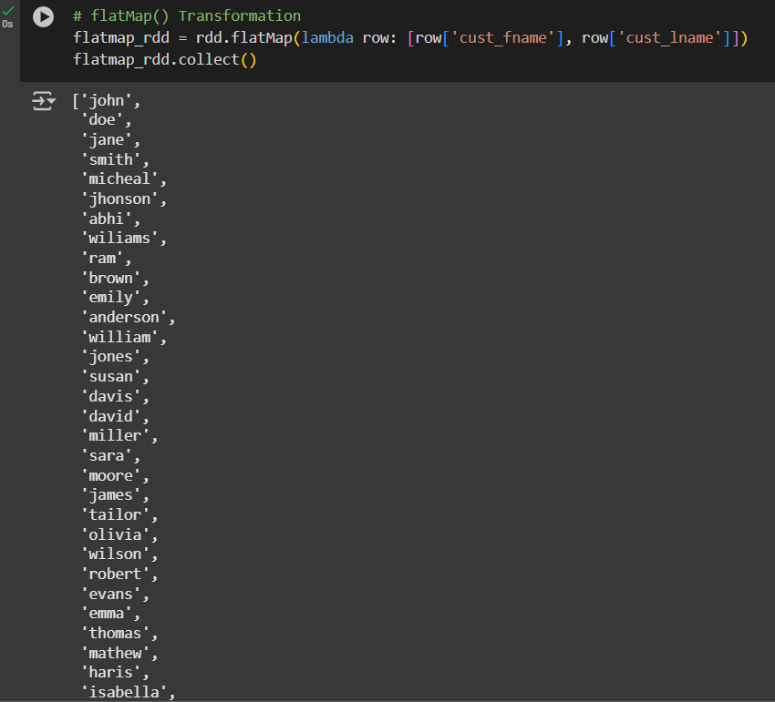

**Actions in PySpark**

* collect() Action
* count() Action
* first() Action
* take() Action
* reduce() Action
* saveAsTextFile() Action

**# Actions in PySpark**

# collect() Action

collect_rdd = rdd.collect()

collect_rdd

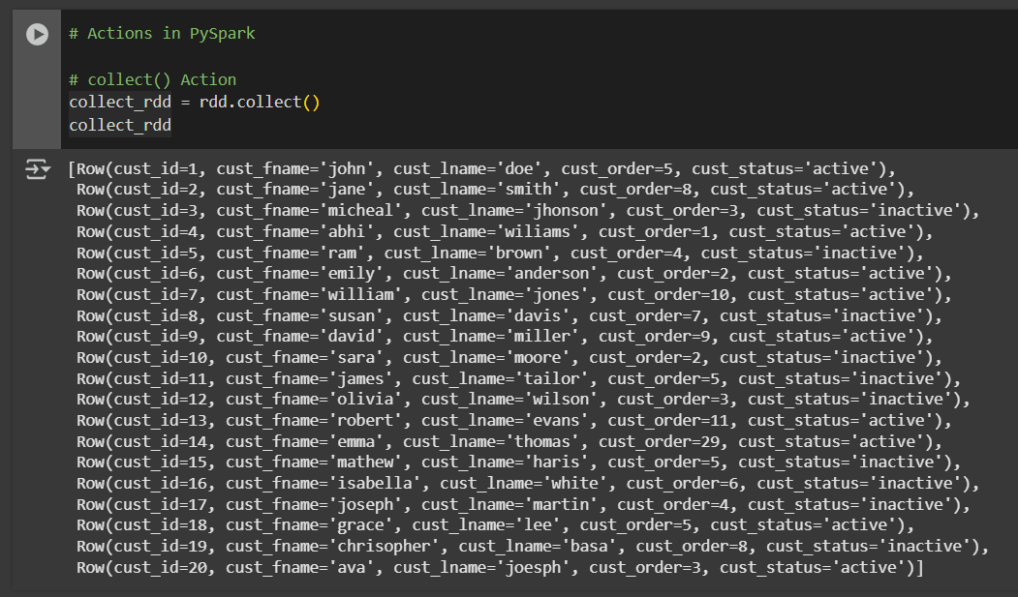

# count() Action

count_rdd = rdd.count()

count_rdd

# first() Action

first_rdd = rdd.first()

first_rdd

# take() Action

take_rdd = rdd.take(5)

take_rdd

# reduce() Action

reduce_rdd = rdd.map(lambda row: int(row['cust_order'])).reduce(lambda a, b: a + b)

print(reduce_rdd)

# saveAsTextFile

saveAsTextFile_rdd = rdd.saveAsTextFile("orders.txt")

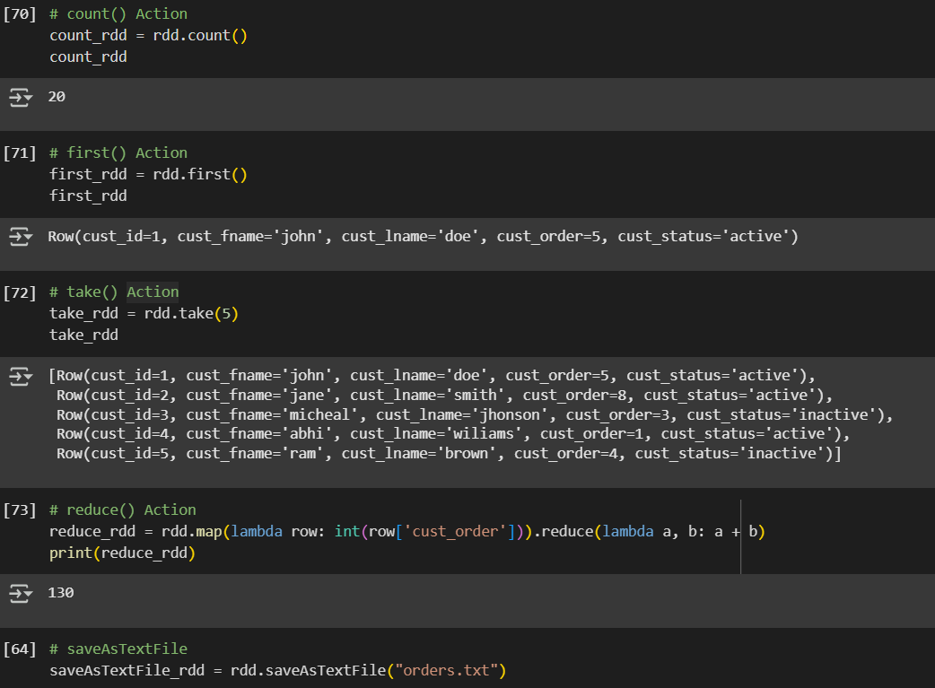

**# Filter Transformation**

from pyspark.sql.functions import col, sum, avg, max, min, count

from pyspark.sql.window import Window

import pyspark.sql.functions as F

df.filter( (col("cust_status") == "active") & (col("cust_order") > 5) ).show()

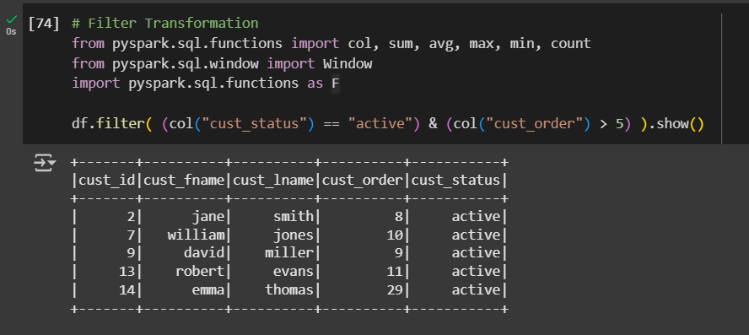

# Joins

data = [(1, "NY"), (2, "CA"), (3, "TX"), (21, "FL")]

df2 = spark.createDataFrame(data, ["cust_id", "state"])

df2.show()

# Inner Join

df.join(df2, "cust_id", "inner").show()

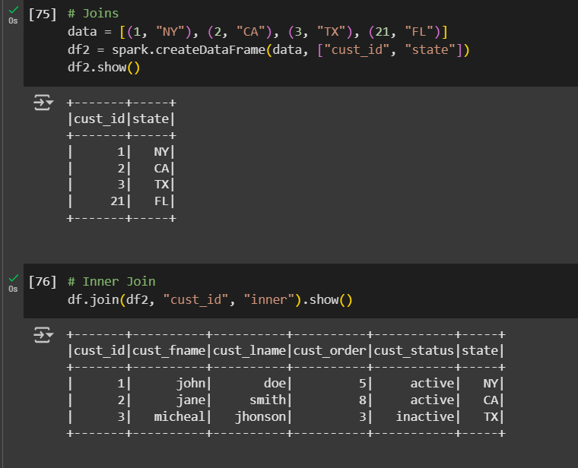

# Left Join

df.join(df2, "cust_id", "left").show()

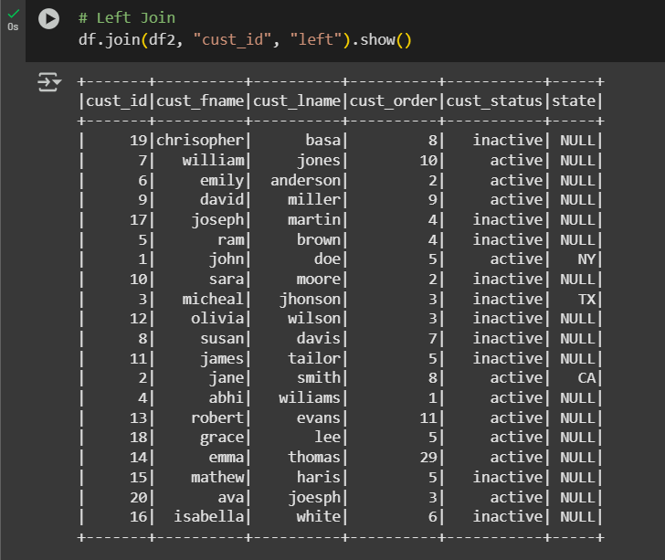

# right join

df.join(df2, "cust_id", "right").show()

# Full Outer Join

df.join(df2, "cust_id", "full").show()

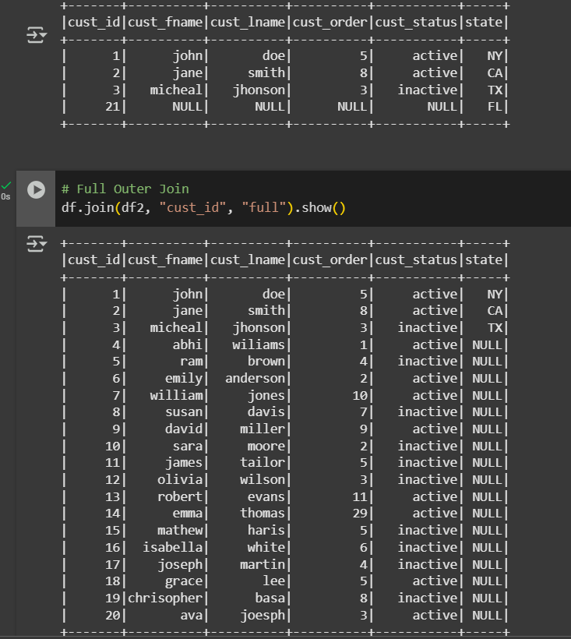

#  Simple Aggregations

df.groupBy("cust_status").agg(sum("cust_order").alias("total_orders")).show()

df.agg(avg("cust_order").alias("avg_orders")).show()

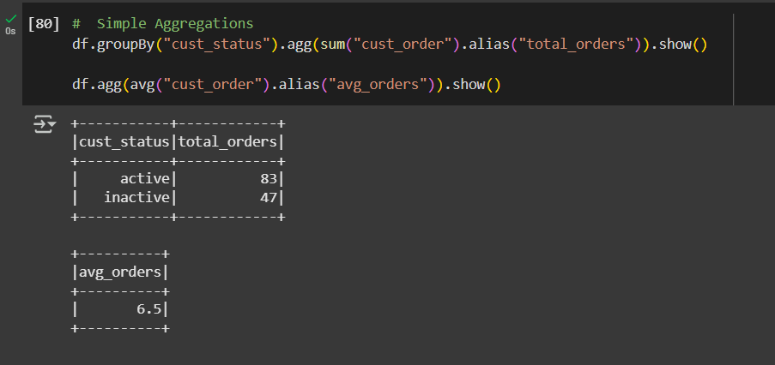

# GroupBy

df.groupBy("cust_status").count().show()

df.groupBy("cust_status", "cust_fname").count().show()

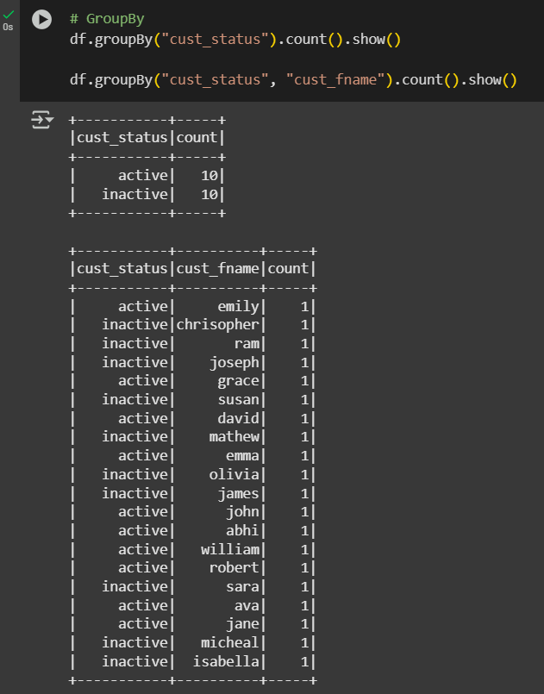

# Window Functions

windowSpec=

Window.partitionBy("cust_status").orderBy(col("cust_order").desc())

df.withColumn("rank", F.rank().over(windowSpec)).show()

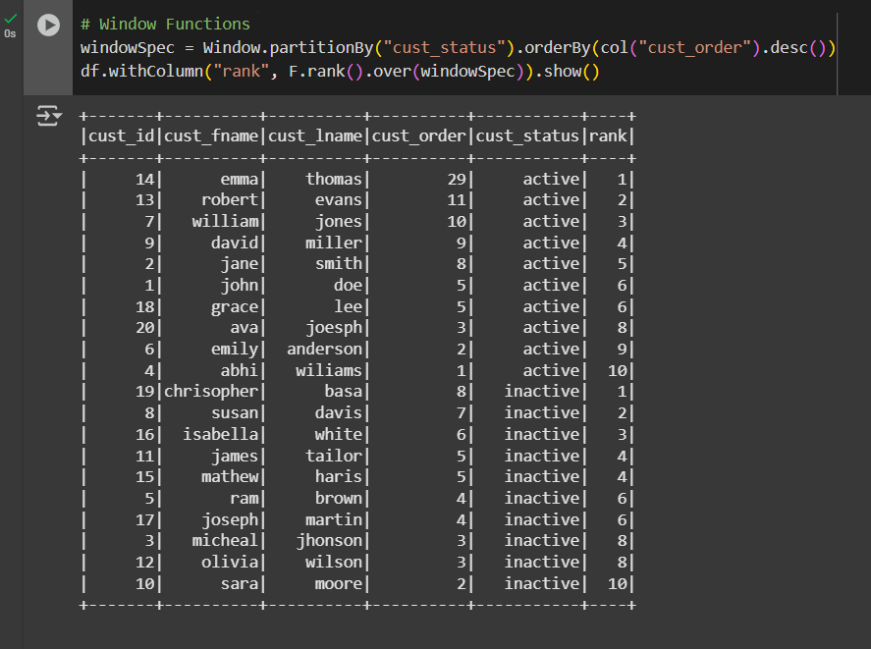

**Submitted by**

**Siva Balan T**